**Title: Normal Mapping**

**1.0 Purpose**

To render and load an .obj model, using a supplied texture and normal map.

**2.0 Method/Results**

Firstly, I loaded in all the files and images I needed for my project, I then started to create a new VBOMesh object, and called this ogre;

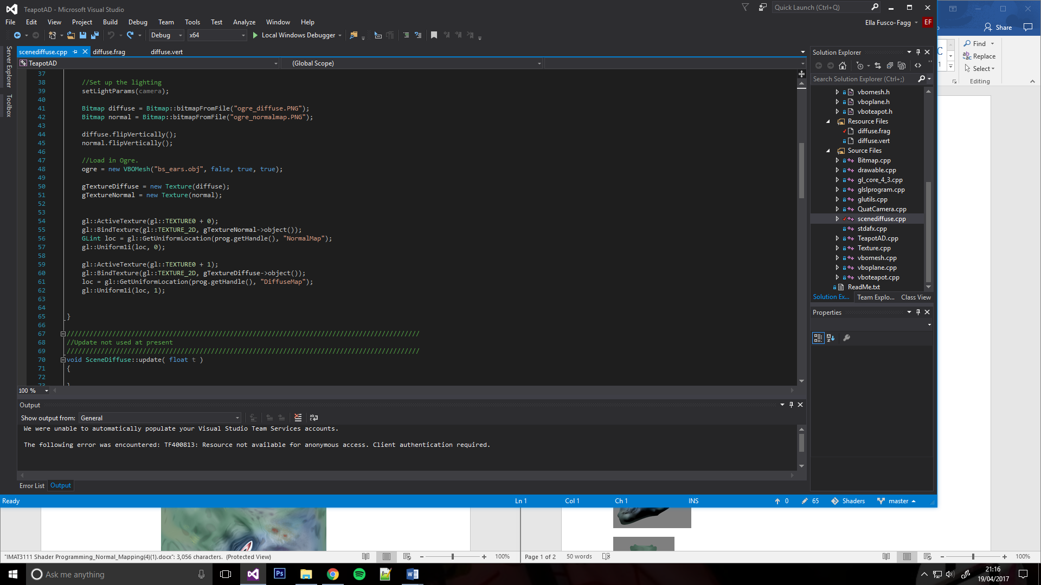

In the screenshot above you can also see that I started to bind the textures to the object, I did both the normal and diffuse map.

In my vertex shader I added the necessary variables and started to calculate and transform the normal and tangents.

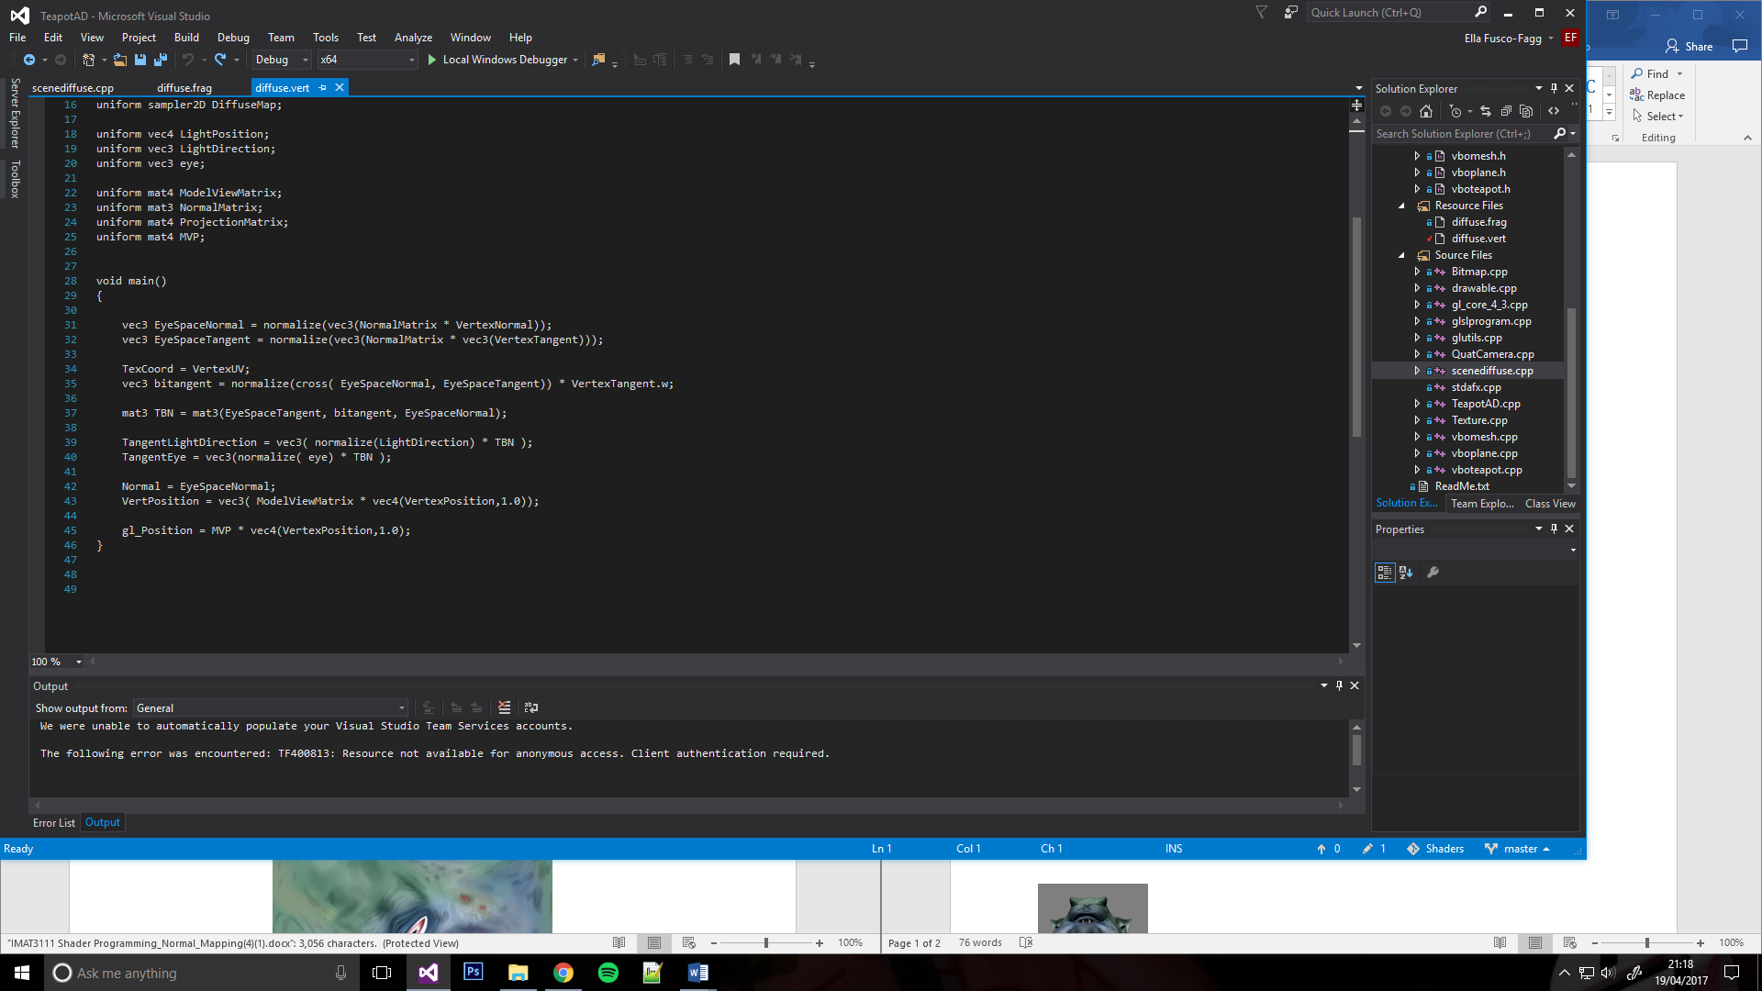

I then built a TBN Matrix to transform my LightDirection and ViewDirection vector, so I could get view space and and eye space as tangent space.



That was all I needed in my vertex shader, I then moved onto the fragment shader in which I was to find the fragment colours by sampling the diffuse colour texture and extract the normals by sampling and converting o 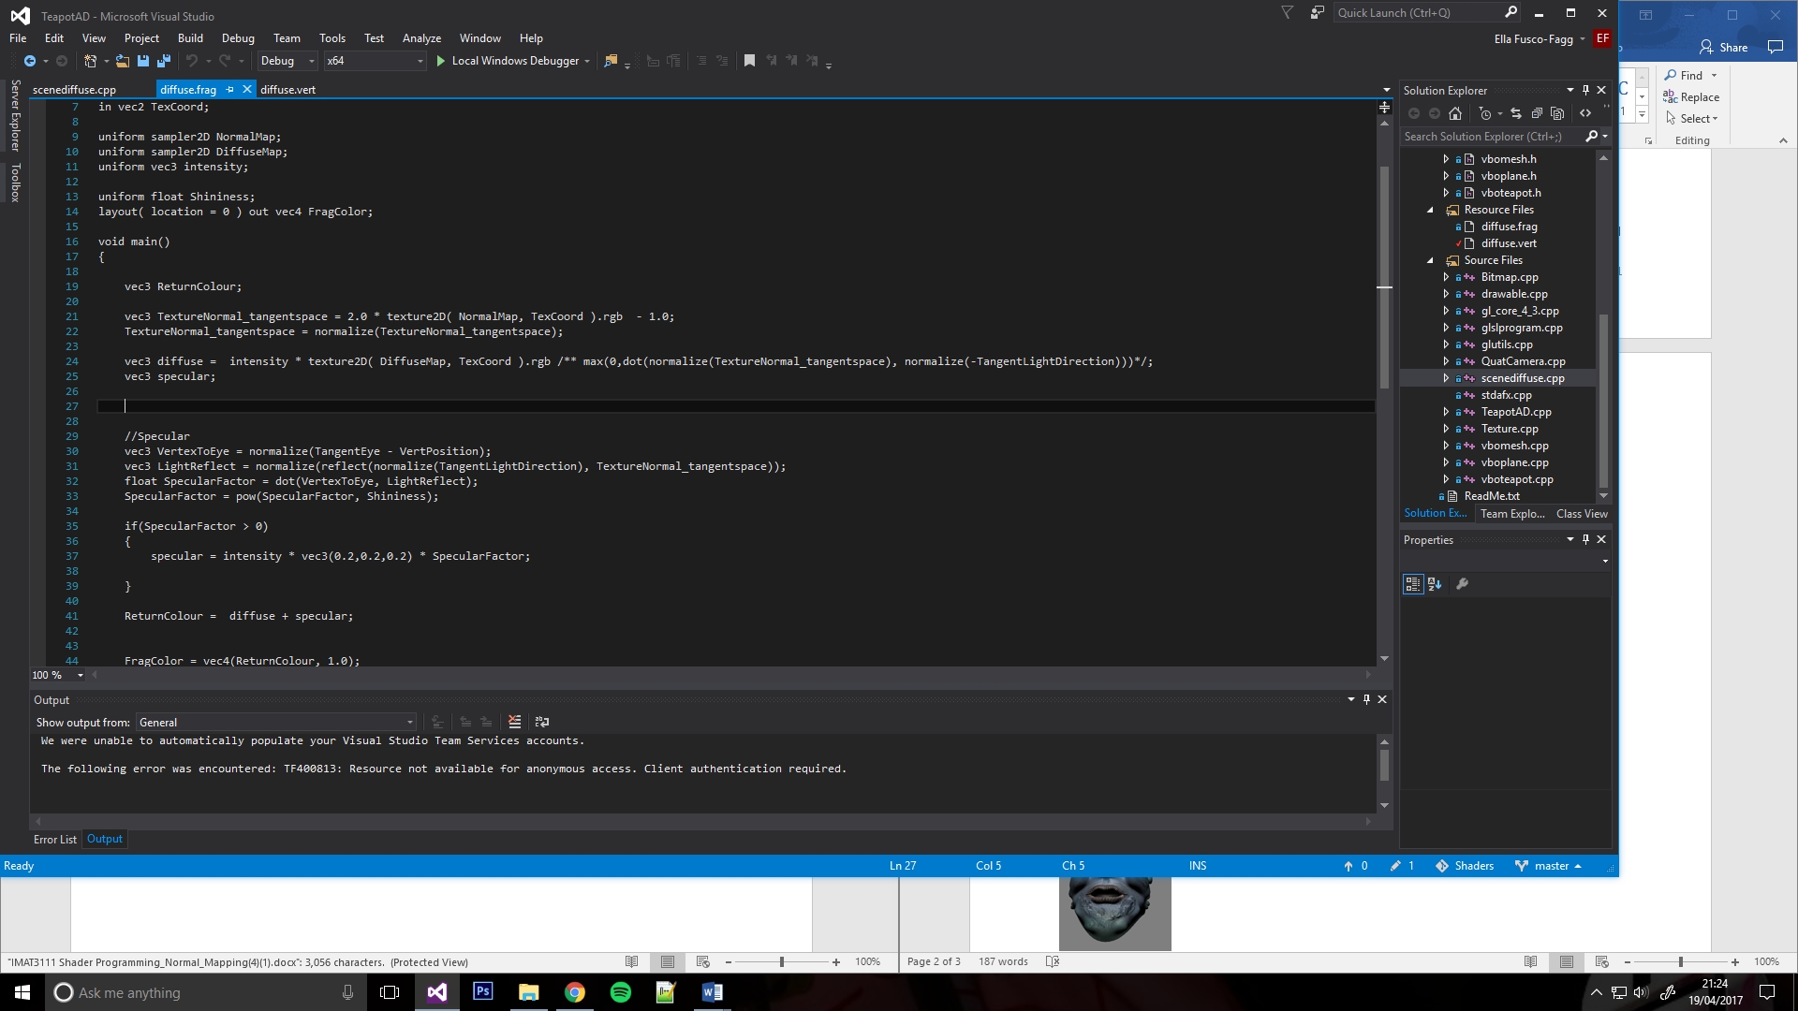the normal map texture.

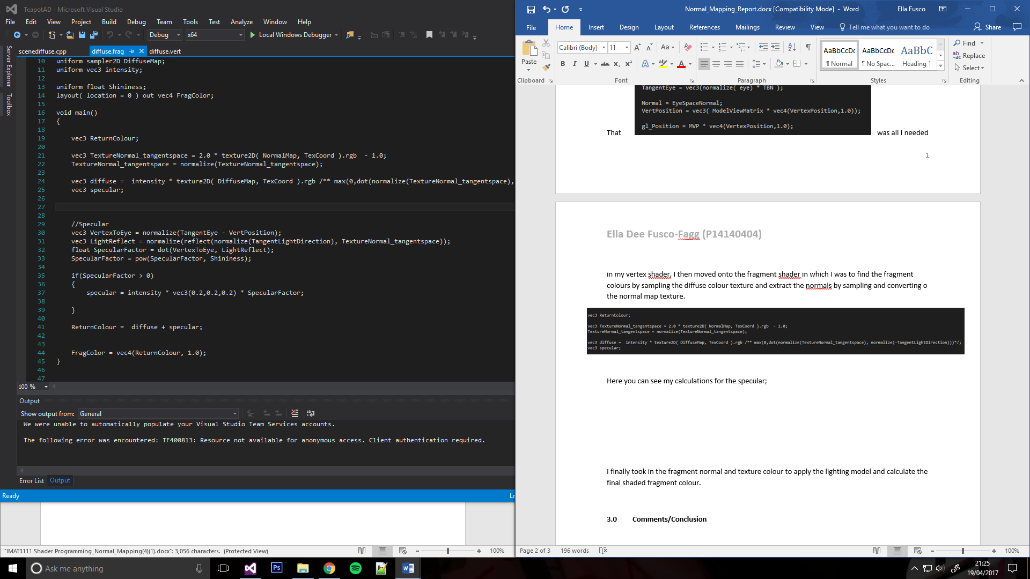Here you can see my calculations for the specular;

I finally took in the fragment normal and texture colour to apply the lighting model and calculate the final shaded fragment colour.



**3.0 Comments/Conclusion**

Here are 4 different views of the ogre with normal mapping and diffuse differences.

